CHATTAHOOCHEE HILLS HOUSE COLORS
All Colors for Both Cluster and Town Homes

Effective January 1, 2007 new paint colors have been approved.
If you paint your house a color that has NOT been approved you are subject to a $25.00 per day fine until the paint color is changed to an approved color.

This means you CANNOT paint your house the color that was formerly approved.

For more information call Bob Gotschall 678-407-6307
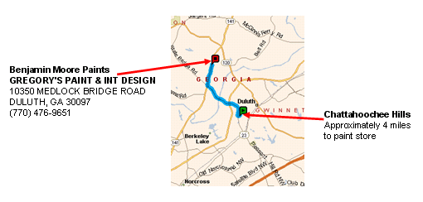

- To get the correct color buy paint at Gregory’s Paint shown above
- Side-by-side houses can NOT be painted the same color
- Doors and Shutters MUST be painted the same color
- All Trim MUST be Benjamin Moore Number 01 White
- Use elastomeric paint on stucco as it has elastic properties which seals the cracks and makes your paint last longer
- If you paint your house a dark color you will need to paint more often

